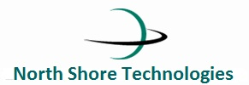

Date:

PO Order Number:

To,

Xyz

Subject:

Brand/Model: Name the brand or model of the item

Price: Mentioned price including taxes

Payment Terms: Mentioned payment terms here

Delivery Item: Mentioned delivery item description here.

Sincerely,

For North Shore Technologies PVT Ltd

NST Logo

Manager Name